**Create Executable from Python Script using Pyinstaller**

**Step 1: Add Python to Windows Path**

To start, you may want to add Python to Windows path.

An easy way to add Python to the path is by [downloading](https://www.python.org/downloads/) a recent version of Python, and then checking the box to ‘Add Python to PATH’ during the installation:

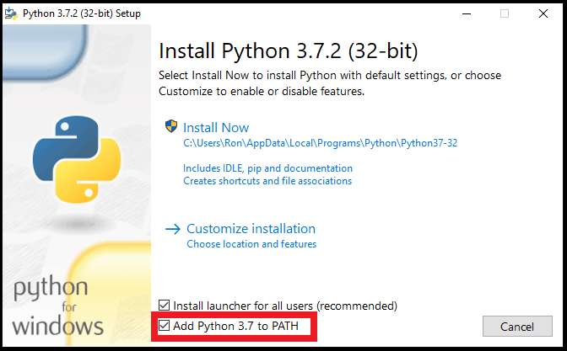

**Step 2: Open the Windows Command Prompt**

Next, open the Windows Command Prompt:

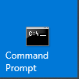

**Step 3: Install the Pyinstaller Package**

In the Windows Command Prompt, type the following command to [install](https://datatofish.com/install-package-python-using-pip/) the *pyinstaller* package (and then press Enter):

pip install pyinstaller

This is how the command would look like:

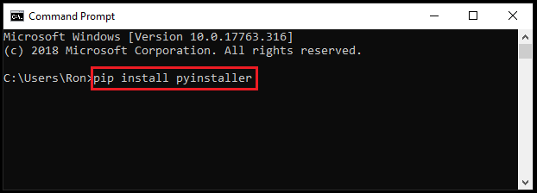

**Step 4: Save your Python Script**

Now you’ll need to save your Python script at your desired location.

For illustration purposes, I created a simple Python script that will display ‘Hello World!’ when clicking the button:

import tkinter as tk

root= tk.Tk()

canvas1 = tk.Canvas(root, width = 300, height = 300)

canvas1.pack()

def hello ():

label1 = tk.Label(root, text= 'Hello World!', fg='green', font=('helvetica', 12, 'bold'))

canvas1.create_window(150, 200, window=label1)

button1 = tk.Button(text='Click Me',command=hello, bg='brown',fg='white')

canvas1.create_window(150, 150, window=button1)

root.mainloop()

I then saved the Python script in the following folder:

**C:\Users\Ron\Desktop\MyPython**

Where I named the Python script as ‘hello’

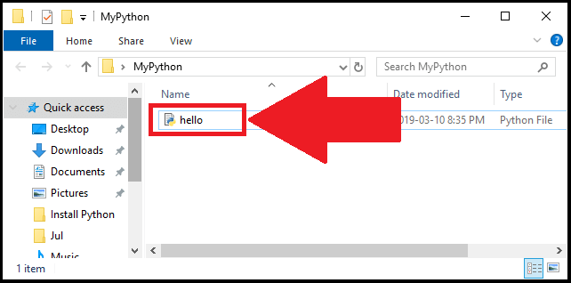

**Step 5: Create the Executable using Pyinstaller**

Now you’ll be able to create the executable from the Python script using pyinstaller.

Simply go to the Command Prompt, and then type:

**cd** followed by the location where your Python script is stored

In my case, I typed the following in the command prompt:

cd C:\Users\Ron\Desktop\MyPython

This is how my command looked like (don’t forget to press Enter after you typed the location where the Python script is stored on *your* computer):

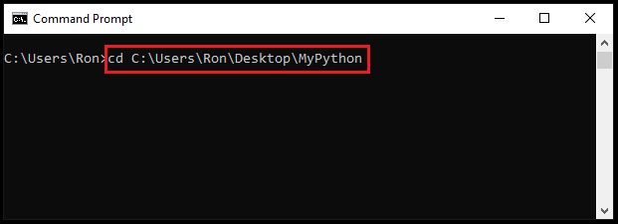

Next, use the following template to create the executable:

pyinstaller --onefile pythonScriptName.py

Since in our example, the *pythonScriptName*is ‘**hello**‘, then the command to create the executable is:

pyinstaller --onefile hello.py

In the command prompt:

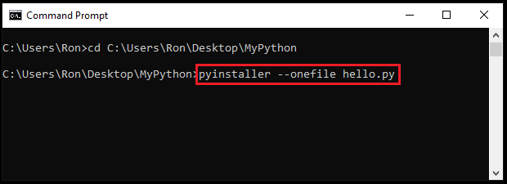

Once you’re done, press Enter for the last time.

**Step 6: Run the Executable**

Your executable should now get created at the location that you specified.

In my case, I went back to the location where I originally stored the ‘hello’ script (C:\Users\Ron\Desktop\MyPython). Few additional files got created at that location. To find the executable file, open the **dist** folder:

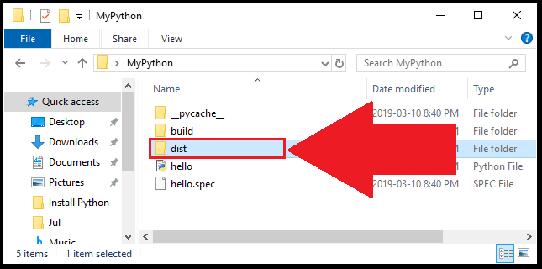

Now you’ll see the executable file:

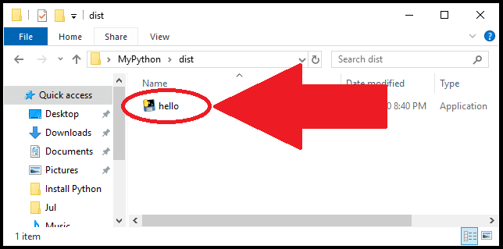

Once you click on the file, you should be able to launch your program (if you get an error message, you may need to install [Visual C++ Redistributable](https://support.microsoft.com/en-ca/help/2977003/the-latest-supported-visual-c-downloads)).

For our example, once you click on the ‘hello’ executable, you’ll see the following display with a single button:

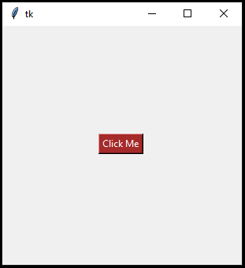

If you click on the button, you’ll see the expression of ‘Hello World!’

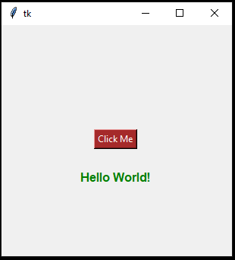

You can read more about pyinstaller by visiting the pyinstaller [manual](https://pyinstaller.readthedocs.io/en/stable/).